- Download a sample dataset of IPL cricket matches with columns like Match Date, Team, Venue, and Result, and create a PivotChart in Excel that shows the total number of matches played by each team.
ANSWERS:
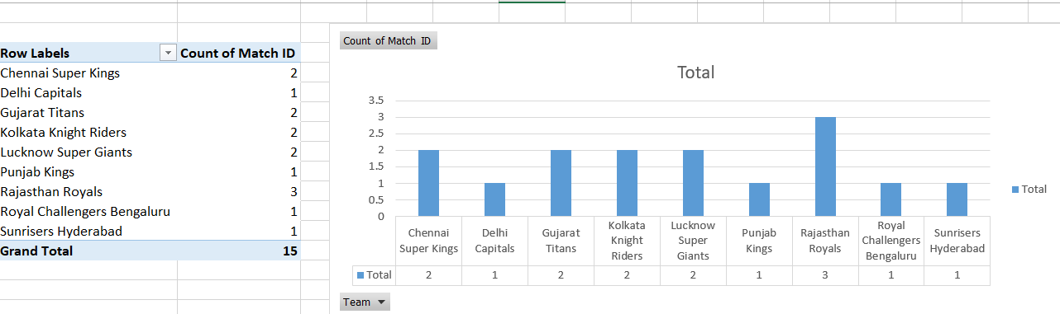

- Add a slicer to your PivotChart that allows you to filter the matches by Venue, so you can quickly see team performance at different stadiums.
ANSWERS:
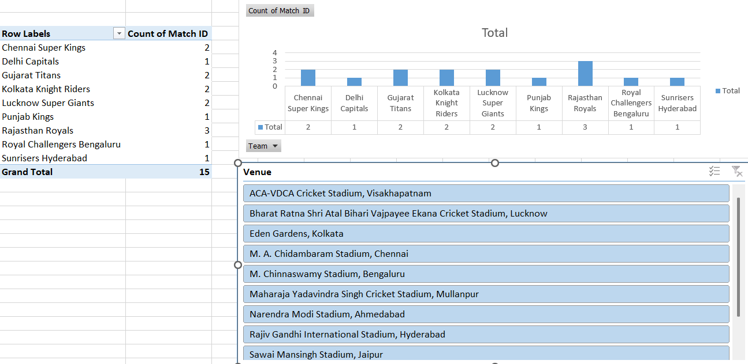

- Insert a Timeline slicer to your PivotChart based on the Match Date column, enabling you to filter and analyze team performance across different IPL seasons or months.
ANSWERS:
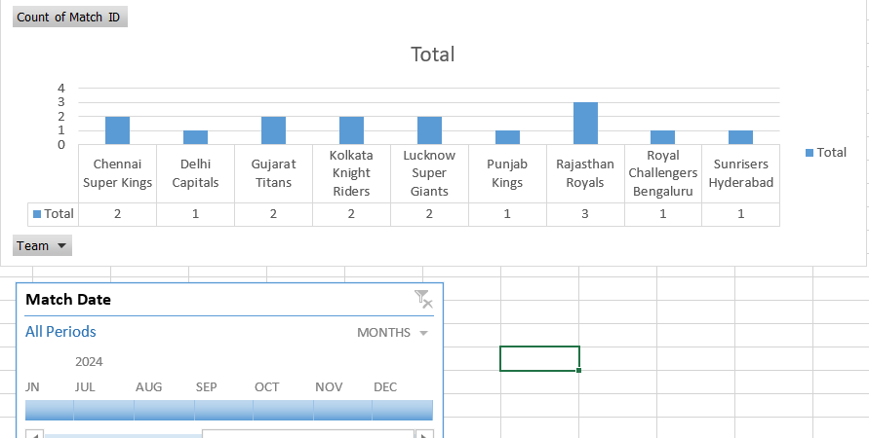

- Build an interactive dashboard in Excel that displays both a bar PivotChart of total wins by team and a line PivotChart of matches played over time, linking both charts to the same Venue slicer and Timeline so filters update both charts together.
ANSWERS:
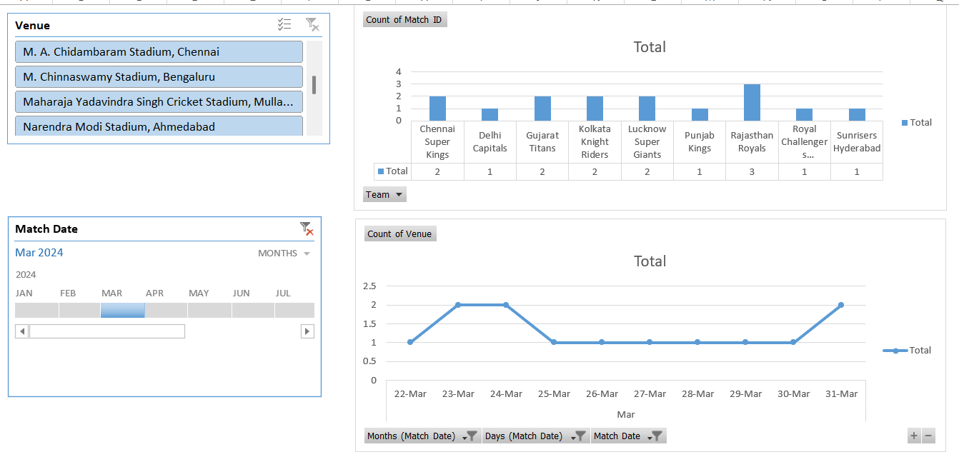

- Create a PivotChart that shows the number of matches won by each team per year, and format the chart to highlight the team with the highest wins in each year using conditional formatting or chart styles.
Hint: Use the Value Filters and chart formatting options to emphasize the top performer.
ANSWERS:
